**SMALL-LABS integration of phasor – 2019-04-18 version**

Current workflow, original elements are highlighted in gray:

**Graphical user interface**

* 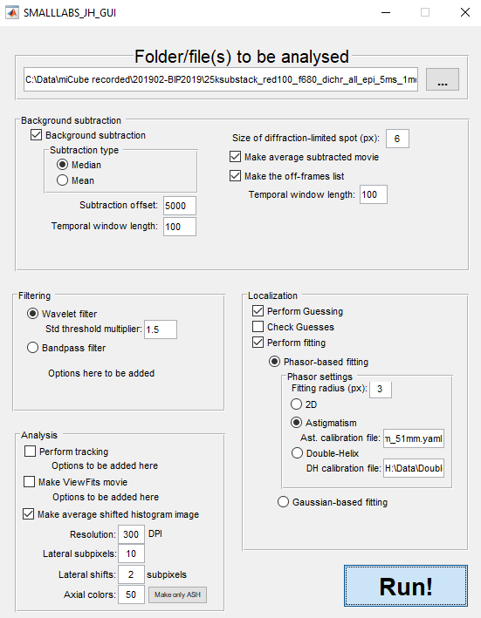GUI_main can be called instead of running SMALLLABS_main, but is not required (!)
* All settings are stored in a .mat file upon closing the GUI or upon running the analysis
* At top, the file location (or folder location) has to be specified. The ... button is functional
* Background subtraction is fully integrated, only offers the possibilities that SMALLLABS originally had.
* Filtering gives the option between Bandpass filter (original, options have to be added here) and Wavelet filter. A multiplier for the threshold has to be specified – this is used to select positions for Guesses: after wavelet filtering, pixels with a value higher than std(image)*multiplier are thresholded, and if the area is ~equal to the size of diffraction-limited spot (circle-equivalent), it is chosen as localization
* Analysis gives the option to specify output. Tracking and ViewFits movie were originally included, and parameters need to be added. Making an average shifted histogram (ASH) is new, and works roughly similar to the same option in ThunderSTORM. The lateral subpixels indicate how big the subpixels of the ASH will be (value of 10 means every pixel will be 10x10 subpixels), the lateral shifts indicate how many pixels outward the ‘uncertainty’ of the localization has to ‘spread’. A value of 2 means that in a 1-subpixel-region around the central subpixel, the intensity will be 50% of the central subpixel. NOTE: This has to be improved upon for >2, and crashes on odd numbers. Axial colours indicate how many z-stacks are made that will overlap in the end. The ‘Make only ASH’ button asks for a *_fits.mat file (which is made during analysis), so that you can make an ASH without re-running full analysis. I will probably add more here, such as axial subpixels, and choice of LUT.
* The localization part gives settings for sub-pixel fitting. The ‘Perform Guessing’ checkbox has to be checked always, as this is the approximate localization. Check Guesses takes long, and I’m not totally sure what it does. If ‘perform fitting’ is selected, sub-pixel fitting will be performed with phasor (new) or Gaussian-based (old; MLE or LS, GPU or CPU; options to be added). Phasor currently supports 2D, astigmatism (both identical to ThunderSTORM’s implementation), and double-helix.
* If the Run! Button is pressed, simply all current settings are passed as parameters to the SMALLLABS_main program, fully enabling SMALLLABS to run without GUI if wanted.

**Workflow**

The workflow of SMALLLABS_JH works roughly as follows:

* After loading a file (or selecting the first file if it’s a folder), image data (TIF) will be transformed to a .MAT file via TIFFstack (fast!).
* Average subtraction is done (if this hasn’t been done identically for this movie before). This performs the median or average subtraction over time (Temporal Median Filter).
* Next, Guesses are made on the movie by a bandpass filter or via a wavelet filter. The wavelet filter is stolen from Jonas Ries’ SMAP. However, after thresholding based on the std(image_after_filter)*multiplier, only regions that are big enough (based on diffraction-limited-spot-size circle-equivalent size) will be selected for guessing. The guesses are really just the centre of these regions.
* Next, an off-frame list is made. Basically, it identifies frames in which two localized molecules are within a 2x diffraction-limited-spot-size with each other.
* Then the subtract-then-fit routine is called. First, the subtraction is performed by subtracting the median/average-subtracted (see average subtraction) ROIs around emitters, only for frames that are ‘off’ (based on off-frame list). This ROIs are based on the diffraction-limited-spot-size (2x dfls+1). Then, fitting is performed on all these ROIs in parrallel, via Gaussian-MLE/LS or phasor. All the fits and the parameters (position, intensity, bg, etc, etc) are stored in the fits-structure at all times.
* Phasor-fitting is as expected. Normally I zoom in from the big dfls-ROI (often ~ 15x15) to the centre to the phasor-ROI (~ 7x7). However, I’ve made edge-case scenarios if the guess is along the edge of the movie. Here, if the guess is f.e. at pixel 2, normally this would be discarded as the 15x15 ROI would be outside the movie. I select instead a 15x15 ROI starting at pixel 1, with the guess offset from the centre, and use this for bg-subtraction. Then, I zoom in as far as possible towards the guess-centre.
* If phasor-2D is wanted, this is the end. If phasor-astigmatism is wanted, a yaml file from ThunderSTORM should be provided as calibration. If phasor-DH is wanted, a .mat file from pSMLM_DH_calibration_SL.m should be provided as calibration. In both cases, I’m adding a fits.zpos in the fits-structure, as the original SMALLLABS has no 3D scenarios. This zpos is currently only used for visualization and exporting the data – it is not yet incorporated in the tracking.
* Next, tracking is performed if wanted. Not entirely sure how this is performed, but the output is as expected – a simple frame-x-y-trackID list. It should be possible to perform tracking with ROI-selection (i.e. cell outlines). I haven’t tried this yet.
* Next, if wanted, an average-shifted-histogram (ASH) is made. Briefly, a new array is made with ~10x the nr of pixels in x and y (subpixels; nr should be provided) compared to the original movie and filled with 0s. Then, all localizations are placed in their correct subpixel-bin. The subpixel-bins next to this one (as far as lateral_shifts/2) are filled with 50% of the intensity (i.e. 2 vs 1). More localizations in the same subpixel-bin or slighly offset are simply added to this value. This is done in 3D-stacks (currently no axial_shifts yet implemented, but this should be done). Then, the individual stacks in 3D are convoluted with a colour-scheme (basically choosing a LUT; extracting the colour of that z-pos, and convoluting that with the original values of the ASH-stack). These colours are overlaid by simply adding them together, and are visualized and stored (export_fig).
  + Before visualizing, the contrast is enhanced by ensuring that 2.5% of the non-black pixels are at saturation value (i.e. the image is scaled untill 2.5% of the non-black pixels are saturated at at least 1 colour).
  + Z-stacks are determined by looking at the middle 98% of the z-positions of the fits.zpos structure, and then evenly divided.
  + The script can be called offline via avgshifthist.m, providing some form of xyz pos, parameters, and original movie size
* Next, a CSV file is made with the ThunderSTORM-structure, so it can be loaded there as well.
* Next, a ViewFits movie is made. This is an avi of the original movie with circled where molecules are localized (good or bad) and tracked. This works correctly with phasor and DH.

**Areas of improvement**

* **Shape of phasor for DH calibration and look-up, could improve resolution and jaccard further**
* Currently, no pixel-size can be entered, this should be done. Perhaps this could change the diffraction-limited-spot size from pixels to nm, and provides a scale-bar everywhere.
* Tracking should be performed in 3D if 3D info is present
* Parrallelization of the filtering/guessing (as this is a frame-based principle I believe).
* Addition of exotic PSFs with phasor – tetrapod and saddle point. Should be done with the tangeant-phasor calibration approach
* Drift correction if wanted, based on cross-correlations (similar to ThunderSTORM approach)
* LUT selection for ASH
* Finishing GUI options of old SMALLLABS options
* Possibility to change storage location (and deletion of) files made by SMALLLABS
* Correct z-pos form MATLAB-ph-astig by multiplying with -1.

**Current results**

**Double-helix phasor**

This is working as good as can be expected, or even better. Current best results obtained are: Jaccard 66% (from full GT file), xy RMSE: 23nm, RMSE axial: 25nm- based on LD, high SNR SMLM-challenge.

This was done with wavelet filter, multiplier 1.4, dflmsz 7, phasor 3, bgsub median, values ~ 100,100 frames (could be ~ 100,400, but doesn’t change tooooo much)

Left: ASH from MATLAB. Right: ASH from **ground-truth** from ThunderSTORM

 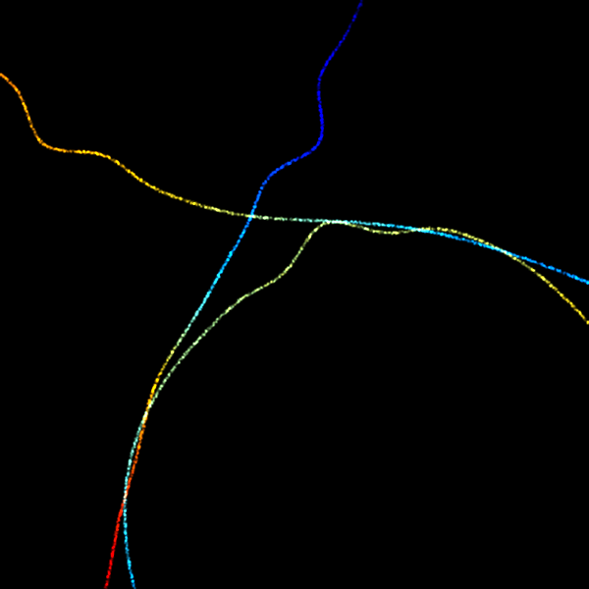

Note: Exact localization position has been chosen so that there is no **offset** from the ground-truth – this introduced some arbitrary offsets at exporting to CSV. I believe this is the fairest approach, as I’m setting an offset=0 at z=0, but this is arbitrary.

Note: localization accuracy of original z-calibration movie is ridiculous: Jaccard of 99.9%, RMSE lateral 5.78 nm, RMSE axial 9.4 nm.

**Astigmatism phasor**

Works as well as ThunderSTORM version – 25k frames gives ~ 35k localizations for both with very similar results (see below; left ASH-matlab, not drift-corr, middle same, but drift-corr in ThunderSTORM, right: analysis in ThunderSTORM; colourbars are not the same). Currently unknown how well this compares to ground-truth. Currently z-pos between MATLAB and JAVA are swapped...

 